April 03, 2012


Traffic.511.org
JavaScript Architecture
and Developers Guide

Version 1.3

Prepared by:
SAIC
David Balmer
Prepared for:
Metropolitan Transportation Commission
101 8th Street, Oakland, CA 94607


555 12th St, Suite 2140
Oakland, CA 94612

Revision Chart

Document Description | Revised by | Date | Version Number
First Internal Draft | David Balmer | 05/26/2011 | 1.0
Updated toolbar and map tab sections | David Balmer | 05/26/2011 | 1.1
Revised to match site functionality | David Balmer | 07/25/2011 | 1.2
Revised to match BETA site functionality | David Balmer | 04/03/2012 | 1.3

Table of Contents

1 JavaScript Architecture Overview 4
2 UI Terminology 7
3 Personalization Data 9
4 Deployment 10
5 Debugging, Profiling and Logging 11
6 Unit Testing 12
7 How Do I? 14
7.1 Set Page Refresh Interval and Ticker Speed 14
7.2 Enable/Disable MapToolBar Items 14
7.3 Change Event bindings 15
7.4 Change Trip Content Rendering 15
7.5 Change Info Window Content Rendering 16

JavaScript Architecture Overview

Namespace: SAIC.Traffic
Web page functionality is contained in an instance of PageController which is globally accessible as SAIC.Traffic.Page
The PageController is instantiated by the PageLoader and manages all components responsible for handling UI events, map interactions and Ajax data requests. These components have control over a limited area of functionality such as scrolling the ticker messages and displaying the map bubbles, which helps to reduce code complexity.
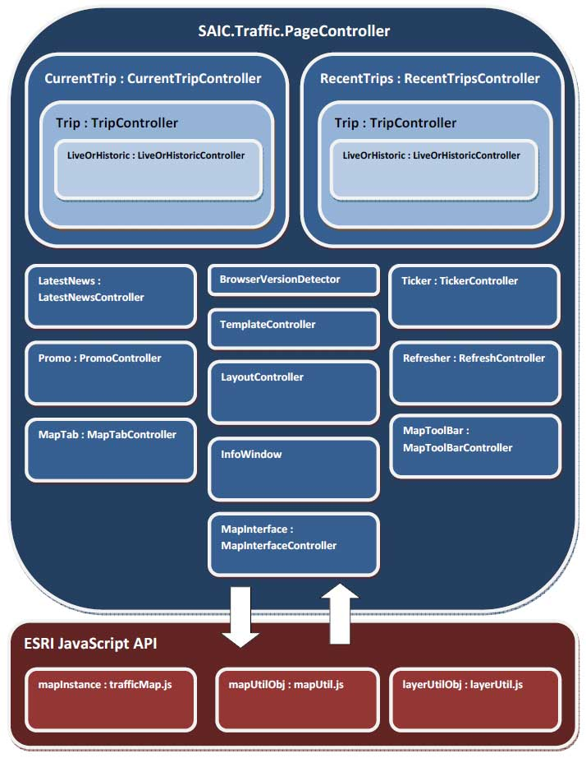
The CurrentTripController manages the UI elements and events for the current trip pane of the side panel, and creates an instance of the TripController to manage the trip results.
The RecentTripsController manages the UI elements and events for the recent trips pane of the side panel, and creates an instance of the TripController to manage the trip results.
The TripController manages the rendering and event handling for a single trip, including summary row hover/click events and synchronization between similar events in the trip results infowindow, and creates an instance of the LiveOrHistoricController for switching between Live and Predicted results.
The LiveOrHistoricController manages the UI elements and events for switching between Live and Predicted results, and synchronizing with similar controls in the Live and Predicted Map Tabs and the current trip pane.
The TemplateController is a self-instantiated Singleton component which uses the jQuery templates plug-in to render data into predefined HTML templates for displaying the map bubbles. Templates are included in the site master page, defined in /Views/Shared/Templates, and are compiled and cached during page load to improve performance.
The RefreshController is instantiated by the PageController to manage the timed refresh interval and notify the PageController of a refresh event.
The MapInterfaceController is instantiated by the PageController to provide the API for interaction between the UI code and map-related code (see trafficMap.js). This API was created so that separate developers could work on each of these parts of the application without having a dependency on implementation details.
The BrowserVersionDetector is a self-instantiated Singleton component that displays a browser upgrade dialog if it detects that the browser is either IE version 8 or Mozilla/FireFox version 8. Once the dialog has been closed, the Page.State cookie is updated so that the dialog is not shown to the user again.
The TickerController is instantiated by the PageController to manage the scrolling ticker messages and will collapse the ticker area if no active messages are available, and will expand the ticker area if was collapsed and new messages become available after refresh.
The StaticLayoutController is a self-instantiated Singleton component used by the static layout pages (FAQ/LatestNews/etc...) to position the footer at the bottom of the browser window when the page content doesn’t take up the full space. This is a simplified version of the LayoutController.
The PromoController is a self-instantiated Singleton component which uses the TemplateController to render available promos into the Emergency/Marketing/Generic promo areas of the page.
The MapToolBarController is instantiated by the PageController to manage the rendering and UI events of the toolbar items displayed within the map panel.
The MapTabController is instantiated by the PageController to manage the rendering and UI events of the map tabs displayed within the map panel, and notifies the PageController to change the page viewstate in response to selections. The Live and Predicted map tabs contain an instance of the LiveOrHistoric controller for between Live and Predicted results.
The LayoutController is a self-instantiated Singleton component which manages the fluid layout of the home page, adding scrollbars if the available space falls below a predefined size, and expanding the map and side panel to fill the available space.
The LatestNewsController is a self-instantiated Singleton component which manages the rendering and UI events of news items displayed in the Latest News panel.
The HotSpotCityController is instantiated by the CurrentTripController to manage the rendering and UI events for the Cities and Hotspots widget used for selecting “Step 2 of 3” and “Step 3 of 3” of the current trip panel.
The DropDownController is instantiated by the CurrentTripController to manage the rendering and UI events for the Main Road, and Cross Road dropdown selections of the current trip panel.

UI Terminology

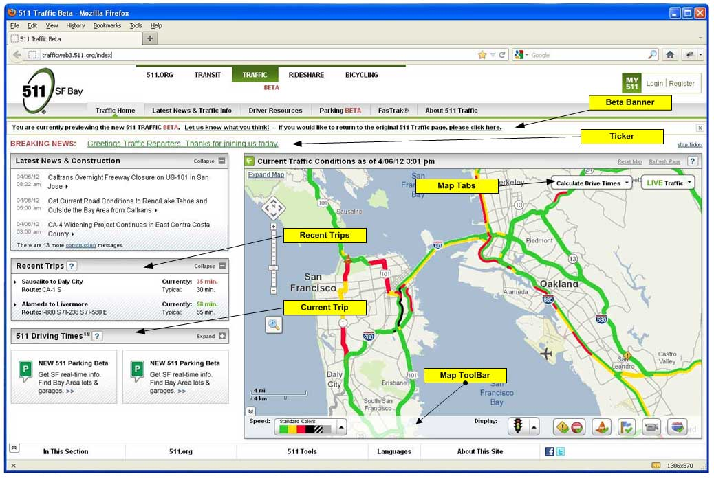
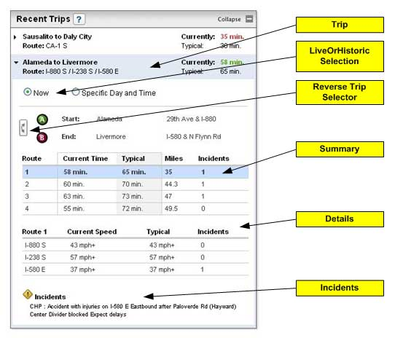

Personalization Data

The PageController contains a State object which is serialized to the cookie in JSON format:
- Trips: an array of Trip objects , each Trip contains:
  - StartNode: {ID, City, MainRoad, CrossRoad, Latitude, Longitude}
  - EndNode: {ID, City, MainRoad, CrossRoad, Latitude, Longitude}
  - SelectedPath: PathNumber of the selected Route
  - HistoricSettings: used to determine PlanType for Predicted trips
    - Day: eg: Midweek
    - Time: eg: 11:45 AM
  - Status: status of the selected route
  - RoadNames: not serialized, unique road names in the SelectedPath, used to display Route: xxx in Recent Trips
  - TravelTime: not serialized, used to display Currently: xxx in Recent Trips
  - HisTravelTime: not serialized, used to display Typical: xxx in Recent Trips
- MapToolBar: currently selected values of each toolbar item
- MapExtent: recent manual extent change
- MapZoomLevel: most recent manual zoom level change
- MapNavigatorExpanded: indicates whether map navigator is expanded (currently not used)
- BrowserVersionNotified: indicates whether notification was displayed, so we don’t show it again
- MapDefaultExtentChanged: indicates whether the MapExtent is different from the default set in trafficMap.js
- MapDefaultToolBarStateChanged: indicates whether the toolbar settings are different from the defaults

Details on how this is serialized including usage of SAIC.Traffic.Data.Attribute.Compress() and Expand()…

Deployment

Including post-build event to combine and minify JavaScript and CSS files…

Debugging, Profiling and Logging

Details on enabling different logging levels, and how LogUIErrors works…

Unit Testing

Using the jQuery QUnit framework to run functional tests against major areas of the application, by simulating user interaction and verifying expected results including map layer visibility and the state of map toolbar items.
Unit tests are divided into subsets of functionality that can be combined to test all aspects of the web application, or run individually during development to obtain a snapshot verification of code changes.
Tests include:
- Expanding the Calculate Drive Times tab, and verifying that speed layers are hidden, and map toolbar items are disabled. Then collapsing the tab and verifying that the page state is restored.
- Expanding the Live Traffic tab, and verifying that the live traffic speed profile is visible, and map toolbar items are enabled. Then collapsing the tab and verifying that the page state is restored.
- Expanding the Live Traffic tab, and selecting the Predicted Traffic, then verifying that the predicted traffic speed profile is visible and map toolbar items are disabled. Then collapsing the tab without closing it and verifying that the page state remains as “Predicted Traffic”.
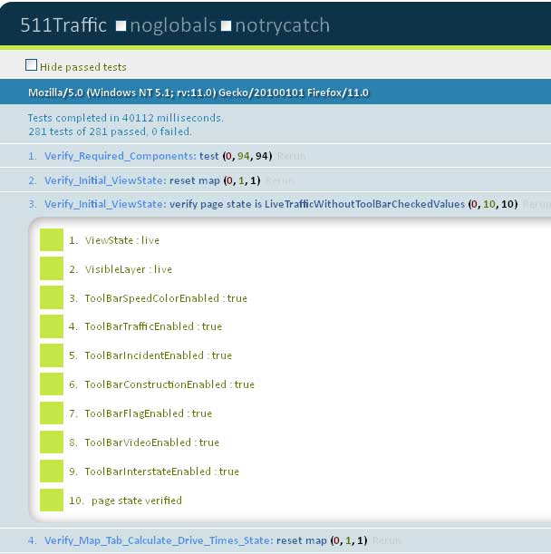

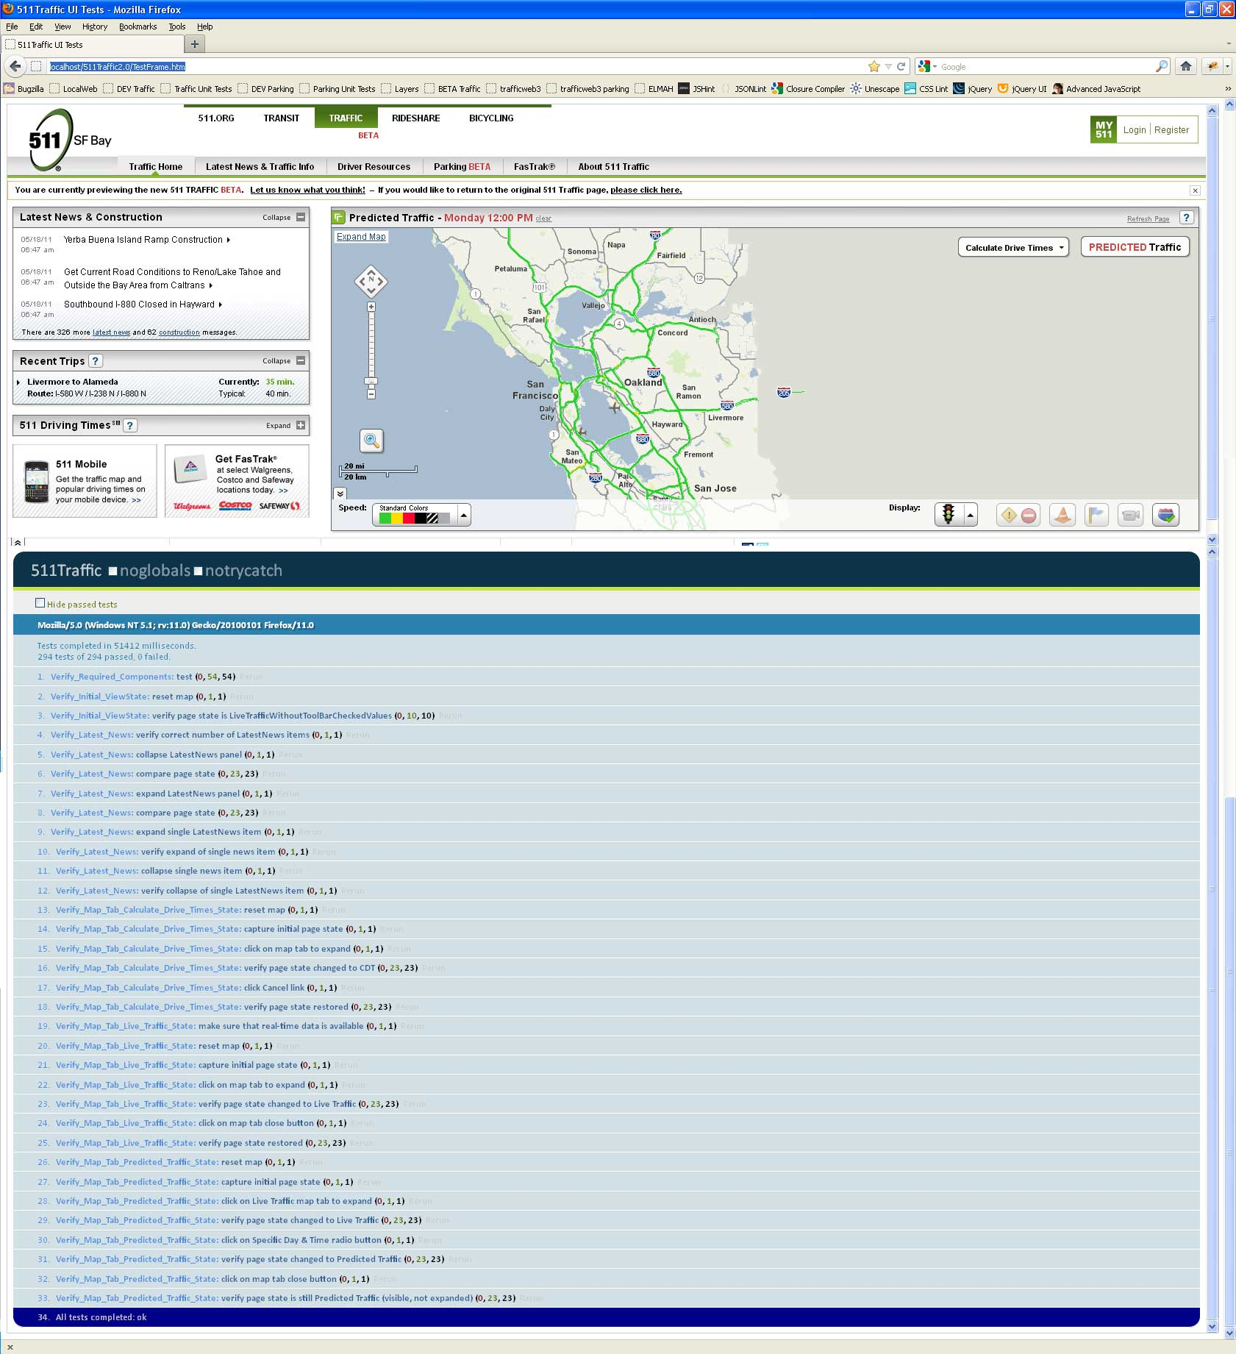

How Do I?

Set Page Refresh Interval and Ticker Speed

Page refresh interval
- SAIC.Traffic.RefreshController has a refresh interval of 3 minutes (180000ms)
Ticker speed

- SAIC.Traffic.TickerController scrolls the message(s) by 1 pixel every 15ms (via scrollDelay)

Enable/Disable MapToolBar Items

Change which MapToolBar items are checked by default

- See SAIC.Traffic.Constants.MapToolBar.DefaultValues defined in Lib.js

Change which MapToolBar items are unchecked/disabled when Calculate Drive Times map tab is expanded

- See SAIC.Traffic.Constants.MapToolBar.CalculateDriveTimes_Expanded_DefaultValues defined in Lib.js

Change which MapToolBar items are unchecked/disabled when Predicted Traffic map tab is expanded

- See SAIC.Traffic.Constants.MapToolBar.PredictedTraffic_DefaultValues defined in Lib.js

Change which MapToolBar items are unchecked/disabled when Live Traffic map tab is expanded

- See SAIC.Traffic.Constants.MapToolBar.DefaultValues defined in Lib.js

Change Event bindings

For cancel link in Current Trip in the side panel

- See SAIC.Traffic.CurrentTripController.Events.Bind()

For cancel link in Step 2 and Step 3 of the Calculate Drive Times in the map tab

- See SAIC.Traffic.MapTabController.CalculateDriveTimes.Events.Bind()

For cancel link in the Predicted Traffic map tab

- See SAIC.Traffic.MapTabController.Init()

For cancel link in the Live Traffic map tab

- See SAIC.Traffic.MapTabController.LiveTraffic.Bind()

For Show/Hide Trip Path checkbox

- See SAIC.Traffic.MapTabController.ShowHidePath.Bind()

Change Trip Content Rendering

For both the Current Trip and Recent Trips in the side panel

- See SAIC.Traffic.TripController Template, Summary.Render(), Details.Render() and Incidents.Render()

Change Info Window Content Rendering

Using jQuery plugin (http://api.jquery.com/jquery.tmpl) with templates embedded into Site.master from /Views/Shared/Templates, then compiled, cached and rendered using the SAIC.Traffic.TemplateController.

Promos displayed on the home page

- Using /Promobox.xml for content
- Using /Shared/Templates/Promo.ascx and SAIC.Traffic.InfoWindow.Templates.AdPromo.Render()

Map Nodes

- Using /Shared/Templates/NodeDetails.ascx and SAIC.Traffic.InfoWindow.Templates. NodeDetail.Render()

Incidents

- Using /Shared/Templates/Incidents.ascx and SAIC.Traffic.InfoWindow.Templates.Incident.Render()

Speed Info

- Using /Shared/Templates/SpeedInfo.ascx and SAIC.Traffic.InfoWindow.Templates.SpeedInfo.Render()

Trip Results Summary

- Using /Shared/Templates/TripResultsMin.ascx and SAIC.Traffic.InfoWindow.Templates.TripResultsMin.Render()

Trip Results Details

- Using /Shared/Templates/TripResults.ascx and SAIC.Traffic.InfoWindow.Templates.TripResults.Render()

